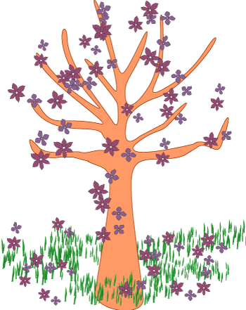 Spring Thaw Rubric
Name: __________________________ Date: _____________________
Criteria | 3 | 2 | 1 | 0 | Points
Before Reading Activities | Student completed both activities | One activity was completed, while the other activity was partially completed | Only one activity was partially completed | Both activities were incomplete
During Reading Activities | Student completed both activities | One activity was completed, while the other activity was partially completed | Only one activity was partially completed | Both activities were incomplete
After Reading Activities | Student completed both activities | One activity was completed, while the other activity was partially completed | Only one activity was partially completed | Both activities were incomplete
Student’s Effort | Student demonstrated an exceptional amount of effort | Student displayed a sufficient work ethnic | Very little effort was demonstrated by the student | Student demonstrated no effort

Score ____ / 12
Additional Comments can be written on the back of this page.

