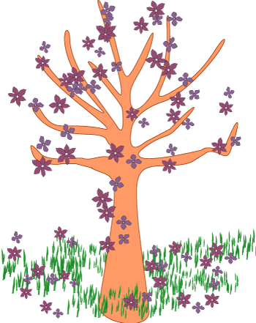 Spring Thaw Checklist
Name: __________________________ Date: _____________________
You are to check these activities off once you have completed them. When all the activities have been completed, turn in this checklist with all your other work.

Pre-reading Activities:
_______ The first two columns of the KWL Chart are completely filled in.
_______ The Springtime Alphabet Worksheet is completed.

During Reading Activities:
_______ The New / Interesting Word Worksheet is completely filled out.
_______ The animal prediction list is completed.

Post Reading Activities:
_______ The website listed was visited, in addition to filling in the third column of the KWL Chart.
_______ The “Spring Acrostic Poem” is completed.

