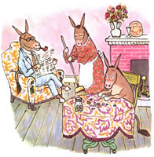
Sylvester and the Magic Pebble
Name______________________________________ _______ Date__________________
Directions: As you read the book, define the words below in your own words or by looking them up on dictionary.com.

- Extraordinary: ____________________________________________________________
_______________________________________________________________________________
- Ceased:____________________________________________________________________
_______________________________________________________________________________
- Gratified: _________________________________________________________________
_______________________________________________________________________________
- Fetlock: ___________________________________________________________________
_______________________________________________________________________________
- Perplexed: ________________________________________________________________
_______________________________________________________________________________
- Bewildered: _______________________________________________________________
_______________________________________________________________________________
- Frantic: ___________________________________________________________________
_______________________________________________________________________________

- Inquiring: _________________________________________________________________
_______________________________________________________________________________
- Dreadful: __________________________________________________________________
_______________________________________________________________________________
- Aimlessly: ________________________________________________________________
_______________________________________________________________________________

