Tyler Smith
10/29/08

Physical Education Written Test
Level: Kindergarten- First Grade

Directions: For questions 1-3, circle the correct letter of the answer ( a, b, c, or d).


1) What movement are these people displaying in this picture?
- Jumping B) Running
C) Walking D) Galloping

2) What movement that we covered in class, involves you to slide your feet together?
A) Hopping B) Sliding C) Jogging D) Skipping
3) When running, if you involve this body part, it helps you run faster, what is it?
A) Head B) Arms C) Fingers D) Eyes
Directions: For questions 4-6, circle the correct picture of the question. These questions are oral, the teacher will demonstrate each movement of each picture. You are then to circle which picture you think is skipping.
4) Which picture is correctly displaying the movement of skipping?
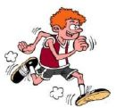

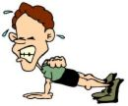

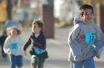
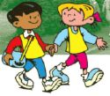
5) What picture shows a NEAR relationship?

