LESSON PLAN by __________Jenny Stiffler____________________________
Lesson: __________Five E Lesson Plan- Plant Parts (Science)______ Length ____50 Minutes_____
Age or Grade Intended _____6th Grade____
Academic Standard(s): 6.4.3 Describe some of the great variety of body plans and internal structures of animals and plants have that contribute to their being able to make or find food and reproduce.
Performance Objectives: After completing the lessons, students will demonstrate their understanding by complete a diagram of the plant by labeling the parts correctly with 90% accuracy.
Assessment: The teacher will assess the students’ diagrams which will have a picture of the plant. The students will be responsible for labeling the parts and writing a brief summary of what the part is responsible for in that plant. The teacher will be checking for understanding in each individual to ensure they know the different components of the plant (which parts make food and which parts are for reproduction).
Advanced Preparation by Teacher: The teacher will need to gather/locate/purchase enough flowers for each student to have one. These need to be larger pedaled flowers so that the students are able to locate the parts easier. The teacher will also need to create enough copies of the worksheet for each student.
Procedure:
Introduction/Motivation: (Engage) I was watering my flowers this week and realized that there were many bees flying around. I wondered what they were after in the flowers and if the bees were important to the flowers’ life cycle. I asked a local greenhouse employee whether or not bees were important. She said that they were very important, but I still do not understand how. To figure out how the bees are important, I need to find out some more information on flowers. I need to figure out what the different parts are and what those particular parts do for the plant. What do you know about flowering plants? Let’s discover the different parts. Follow with me as we discover the plant world. (Bloom’s Knowledge, Comprehension, Gardener’s Auditory, Naturalist)
Step-by-Step Plan: 1. (Explore) Give each student a flower. This is a flower from the greenhouse and it is very similar to my flowers at home. These flowers are here for us to discover more about the flowering plants around us.( Bloom’s Application, Analysis, Gardener’s Tatical, Visual, and Verbal)
The teacher will guide the students as they dissect their plants. The teacher will explain what each part of the plant is and what purpose it serves. The teacher can use the teacher note sheet attached. The students can take notes if they wish to keep track of each item.(The top portion of the teacher page may be reproduced so that the students have a reference.)
2.(Explain) Share the findings together. Fill out the blank copy of the flower worksheet. So, how does this new information help us answer my question about the bees? Can I now appreciate the bees because I understand their importance? (Bloom’s Application, Gardener’s Visual, Tatical)
3.(Elaborate) The bees are attracted to the pollen in the flower. What do you think attracts the bees to this particular part of the plant? Which part of the flower are the bees really interested in? Do you think that the bees would still come if this part of the plant disappeared? Why or why not? The teacher would lead the students through these questions and help to guide them to the correct answer. The students may share ideas here to help their classmates gain a better understanding of the process. This could also be linked (here) to the pollination lesson which could occur before or after this lesson.(Bloom’s evaluation, Comprehension, Gardener’s Verbal, Naturalist)

Closure: (Evaluate) The teacher will give the students the worksheet to complete. The teacher will allow time to complete the worksheet. The teacher will then link this lesson to the upcoming lesson which could be some of the following topics (depending on the classroom setup): pollination, comparison of plant and animal reproduction and survival, photosynthesis, plant cell vs animal cell, etc. The teacher will incorporate this information learned into the upcoming lessons as well as a reference point. (Bloom’s Comprehension, Application, Gardener’s Visual)
Adaptations/Enrichment: For a student who is allergic to flowers, the teacher will locate a website where the student can dissect the flower virtually. If a student is unable to read, the teacher could allow a verbal conversation between him/herself and the student to check for understanding of the flower and the concepts the teacher wishes that the student obtain. The teacher would give a word bank to the more advanced students and ask them to draw a flower and label its parts. The teacher could also have those students locate more detailed descriptions and parts of the plant to be included in their worksheets.
Self-Reflection: After the lesson has been taught, evaluate the effectiveness of your teaching and planning. Was it successful? What would you do differently next time to improve the lesson? Include any comments that you received by an observing adult or the students you taught. Did the students use their information properly, or did they spend too much time messing with the flowers? Did the teacher allow enough time for completion? Did the assessment show what I hoped to gather from the students?

Can you fill in the names for the different parts of the flower?
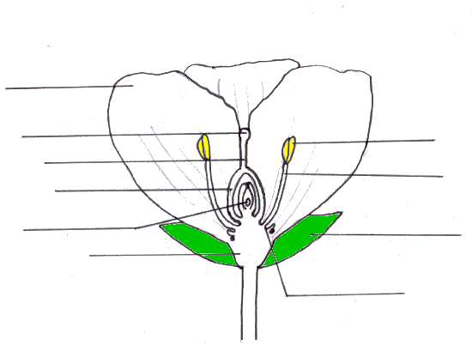

Now, Explain in your own words what each part of the flower does for the plant.

Why do you think that the bees are essential to the life of the flower?

