Student Name: Gymnastic/Balance Written Test
(Match the picture to the term by drawing a line connecting the two)

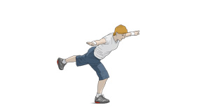 Back Support Position
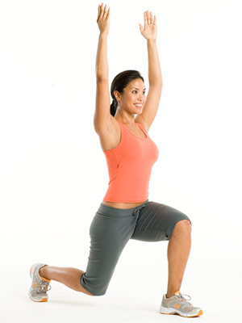 Airplane Position
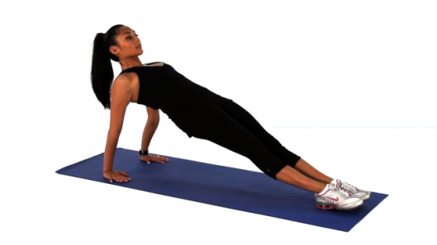 Lunge Position
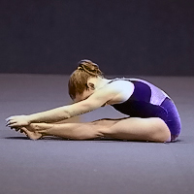 Pike Position

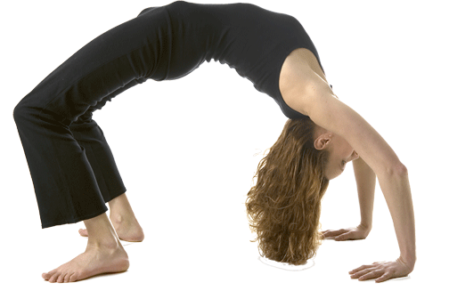 Front Support Position
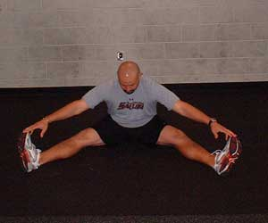 Bridge Position
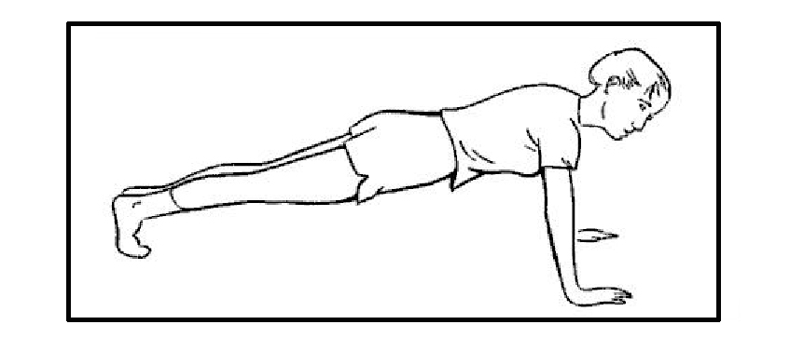 Straddle Position
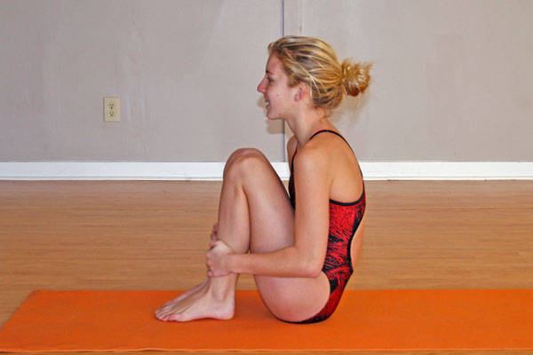 Tuck Position

Reference: (Lee, K. Thomas, J. Thomas, Pg 183)

