Archery Reciprocal Task Sheet
Name: Partner: Date:
Skill: Releasing Arrows
To the Students: This task is performed in groups of three: arrow shooter, arrow retriever, and observer.
Arrow Shooter: Shoot two ends (12 arrows total) into the target.
Arrow Retriever: Retrieve the shooter’s arrows and return them to the quiver after both ends are shot.
Observer: Examine the shooter’s form by comparing his/her performance to the criteria listed below. Check what the shooter can do and what he/she needs to practice on at the bottom of this sheet. Tell the shooter what he/she does well and what needs to be corrected.
*Rotate jobs after the shooter has successfully shot two ends at the target.*
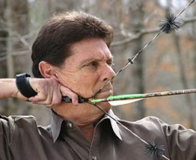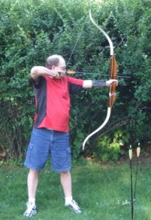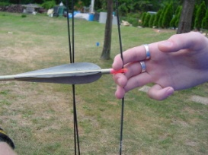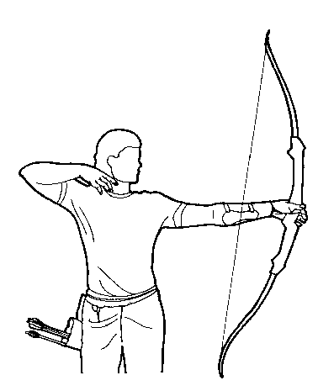
1 2 3 4 5
Things to look for while releasing arrows (criteria):
Can Do Needs Practice
- The archer has a solid anchor point. ______ ______
(arrow is anchored at nose, chin, or cheek)

- The archer has a straight bow arm, other arm is up ______ ______
high, the elbow should be level with shoulders.

- Archer maintains hold for a few seconds and relaxes ______ ______
his/her body by taking a few deep breaths.

- Archer should relax fingers letting the string slip off. ______ ______

- Archer should maintain form until arrow hits the target. ______ ______

