Community Unit Plan
Kindergarten
Kristi Staton
EDUC327
December 2, 2011

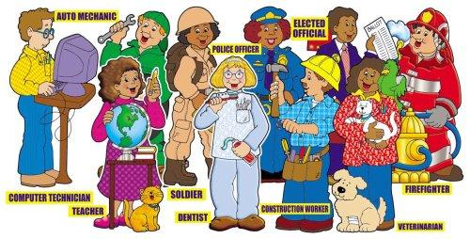

Table of Contents

Title of Pages Page Numbers

Introductory sheet…………………………………………………………...3-5
Standards…………………………………………………………………….6
Unit Web……………………………………………………………………...7
Letter to parents…………………………………………………………..…8
Trade books…………………………………………………………….........9-16
Bulletin board……………………………………………………………….17-18
Field trip and guest speakers……………………………………………..19-20
Technology and literature…………………………………………………21
Pre-test/Post test……………………………………………………………22-26
Lesson Plans
Lesson #1 …………………………………………………………...27-31
Lesson #2 ……………………………………………………….......32-36
Lesson #3 ……………………………………………..…………….37-46
Lesson #4 …………………………………………………………...47-50
Lesson #5 ………………………………………………..………….51-54
Lesson #6…………………………………………………………...55-57
Lesson #7……………………………………………………………58-60
Lesson #8…………………………………………………………...61-62
Lesson #9……………………………………………………………63-64
Lesson #10………………………………………………………….65-66
Resources……………………………………………………………………67

Introductory Sheet
Typical Kindergarten Learner:
A child in kindergarten wants to learn all about the world around them and how it works. He or she will use their curiosity to learn more about the world around them. Children at this age tend to show interest in books although most “read” a book by telling a story based on the pictures. PBS parents (2011) states that students have not mastered fine motor skills such as holding pencils or cutting with scissors but have some development of the fine motor skills. Children in kindergarten also are able to interact with other students. Their social skills are important for success in school and students at this age often get along well with others, share, and take turns. The National Association for the Education of Young Children (NAEYC) states that most five-year-olds can begin to combine simple ideas into more complex relations. Students need to be placed in an environment that is filled with abundance supply of printed materials that stimulate the development of language and literacy skills in a meaningful context (NAEYC, 2008). PBS parents (2011) alongside the NAEYC (1986) agree that at this age students come to school with an interest in the community and the world outside their own.
Rationale:
Because students come to Kindergarten ready to expand their world beyond their homes to larger neighborhoods and communities students need to participate in this unit. While exploring the world around them students will learn the importance of a community and how people are able to help their community. Students will also be able to gain the concept that they themselves are community helpers and can help the people around them. By learning about community helpers, students will be able to recognize the importance of how a community works and what it takes to be part of a community. Students will explore different community helpers and the tools they use to help other members of the community. Students will also have a chance to explore different types of community helpers and what they may want to do when they are older. The students participating in this lesson will plan and follow through on a service project to help their own community.
Goals:
- Give examples of how to be a responsible family member and member of group.
- Give examples of people who are community helpers and leaders and describe how they help us.
- Recommend ways that people can improve their environment at home, in school, and in the neighborhood.
- Explain why people in a community do different jobs.
- Locate and describe places in the school and community
- Identify and describe different kinds of jobs that people do and the tools or equipment used in these jobs.

Learning Objectives:
O1: The student will identify at least 3 characteristics of a friend on a piece of paper.
O2: In a game of kickball students will play according to the rules 100% of the time.
O3: Given five community members, students will match at least four correctly to the appropriate tools.
O4: Given 5 community helpers, student will match at least 4 community helpers with the appropriate description.
O5: Given a community member, the student will create a poster about their community member and receive at least a 7/10 on rubric.
O6: Given a journal, students will acknowledge their role in their community by writing a message and drawing a picture of an act of kindness that helped someone in their community with 80% accuracy.
O7: Given a paper with pictures of different places in and outside of school, students will circle the appropriate pictures that show places in the school with 90% accuracy.
O8: Given a job, the student will participate in class service project 100% of the time.
O9: Given an occupation, student will use the appropriate tools to role play their job in the community 90% of the time.
O10: Given a journal, student will use pictures and messages to explain what they want to be when they grow up and how they will help the community with 80% accuracy. (Rubric)

Standards Matrix
Standard Lesson | #1 | #2 | #3 | #4 | #5 | #6 | #7 | #8 | #9 | #10
Social Studies
K.1.3 |  |  |  | X |  |  |  | X
K.2.1 | X |  | X | X | X |  |  |  | X
K.2.3 |  | X
K.2.4 |  |  |  |  |  | X |  | X
K.2.5 |  | X
K.3.3 |  |  |  |  |  |  | X
K.3.6 |  |  |  |  |  | X
K.3.7 |  |  |  |  |  |  |  | X |  | X
K.4.1 |  |  |  |  |  |  |  |  |  | X
K.4.2 |  |  |  |  | X |  |  |  | X
K.4.4 |  |  |  |  | X
Language Arts
K.1.1 |  |  | X
K.1.22 | X |  | X
K.2.1 |  |  | X
K.3.2 |  | X
K.3.3 | X
K.4.3 |  |  |  |  | X | X |  |  |  | X
K.4.5 |  |  |  |  | X | X |  |  |  | X
K.4.6 |  |  |  | X
K.4.7 |  |  |  |  | X
K.7.1 |  | X |  | X
K.7.2 |  | X |  | X
PE
K.1.1 |  | X
K.1.3 |  | X
Math
K.2.1 |  |  |  |  |  |  |  | X
K.6.2 |  |  |  |  |  |  |  | X

Unit Web
December 2, 2011
Dear Parents/Guardians,
Hello! I would like to take this time to explain to you what we will be doing in social studies during the next couple of weeks. As you see your child has begun to explore their environment around them and as a class we will begin a unit on community. During this unit we will cover what a community is, community helpers, tools community helpers use, how to be a good community helper, and plan a service project to help our community. We will talk about many community helpers and explore a police car and fire station. We will also be practicing responsibility and practice daily jobs during the school days.

We will work in small groups to create posters and even practice being different community helpers. Towards the end of the unit your child will become familiar with ways to help the community and it is my hope that they are able to demonstrate being a community helper both in and out of school at home.

We are very excited to begin this new unit and learn about our community. If you are interested in setting up a time to talk with the class about how you contribute to the community please feel free to contact me to try to work out a time that would fit into our unit. Also, I will gladly take any volunteers to help with our service project. Another letter will be sent home when we have decided on a project to work on. If you have any questions or comments please feel free to contact me.

Sincerely,
Miss Kristi Staton

Annotated List of Trade Books for Community Unit
Adamson, H. (2004). A day in the life of a construction worker. Mankato, Minn.: Capstone Press.
A Day in the Life of a Construction Worker explores a typical day that a construction worker has. The book describes the occupation of a construction worker. It also goes through and describes what the job requires. The book shows how hard working and dedicated a construction worker is. This book uses both pictures and words to show the occupation of the construction worker. Since many students cannot read in kindergarten, this book will be set aside in the literature bucket for children to look back throughout the unit. Students will use this book to look at while doing research projects for the unit.
Adamson, H. (2004). A day in the life of a dentist. Mankato, MN.: Capstone Press.
A Day in the Life of a Dentist explores a typical day that a dentist has. The book describes the occupation and the tasks dentists do throughout the day. The book shows pictures of the dentist cleaning teeth. This book shows children how dentists provide important services to the community. This book used both pictures and words to help children understand what a dentist does in a normal day. Since many students cannot read in kindergarten, this book will be set aside in the literature bucket for children to look back throughout the unit. Students will use this book to look at while doing research projects for the unit.
Bridwell, N. (1985). Clifford and the grouchy neighbors. New York: Scholastic.
Clifford and the Grouch Neighbors is about a girl named Emily Elizabeth and a Big Red-Dog named Clifford. Email and Clifford had neighbors who didn’t like Clifford at all. Clifford tried to be a good friend and visit the neighbors. He even tried to sing along with them when they would sing. Clifford was so big that the he would sometimes block the sun from getting to the plants. Clifford tried to help the neighbors but the neighbors would just yell at him. One day Clifford was able to say the neighbors’ cat and ended up being a hero. This book shows that you should always try to be a good friend and eventually people will stop judging and accept you. This will be introduced during our friendship lesson and will be used to show students that it pays off to always try to be a good friend even when the other person may not being doing the same.
Bridwell, N. (1994). Clifford the firehouse dog. New York: Scholastic.
Clifford the Firehouse Dog is about a girl named Emily Elizabeth and her Big-Red Dog named Clifford. In this story Clifford is introduced to the role of firefighters. Clifford learns the importance of fire safety and gets a chance to be a fire rescue dog. Clifford learns how to put out fires and do things that firemen do in their daily lives. At the end of the book a list of fire safety rules are listed. This book will be incorporated into the lesson that teachers about different community helpers. Students can use this book to research unit projects. Students also will be able to look through this book to help develop questions when the fireman visits as a guest speaker.
Corwin, O. J. (2007). When I grow up. New York: Abrams Books for Young Readers.
When I Grow Up is about a book that shows children they can grow up to be anything. The book used animals to show their individual talents, for example a firefly can glow in the dark and a spider can spin elaborate webs. This book gets children thinking about their own talents and realizing that they can be anything they want to be when they grow up. This book will be used to show children different occupations that they can have when they grow up. Children can look back at this book when completing unit projects and while in reader’s workshop. It will be placed in the community literature bucket.
Deedrick, T. (1998). Bakers. Mankato, Minn.: Bridgestone Books.
Bakers is a book about the job of a baker. It introduces the tasks that they perform. The books starts off by describing the clothing a baker needs to wear and why they wear it. The book then shows the tools that the baker used and the education required to be a successful baker. Since many students cannot read in kindergarten, this book will be set aside in the literature bucket for children to look back throughout the unit. Students will use this book to look at while doing research projects for the unit.
Hayward, L. (2001). A day in the life of a police officer. New York: Dorling Kindersley Pub..
A Day in the Life of a Police Officer shows a typical day a police officer has at work. The book uses a question and answer format to show children why police officers are important. The book also shows different ways in how they are able to help in our community. This book uses both pictures and words to show children the occupation of a police officer. Since many students cannot read in kindergarten, this book will be set aside in the literature bucket for children to look back throughout the unit. Students will use this book to look at while doing research projects for the unit.

Hayward, L. (2001). A day in the life of a firefighter. New York: Dorling Kindersley Pub..
A Day in the Life of a Firefighter shows a typical day a firefighter has at work. The book uses a question and answer format to show children why firefighters are important. The book goes through several ways on how a firefighter helps the community such as putting out fires and saving animals stuck in trees. This book uses both pictures and words to show children the occupation of a firefighter. Since many students cannot read in kindergarten, this book will be set aside in the literature bucket for children to look back throughout the unit. Students will use this book to look at while doing research projects for the unit and to generate questions for our guest speaker.
Hayward, L. (2001). A day in the life of a doctor. New York: DK Pub..
A Day in the Life of a Doctor shows a typical day a doctor has at work. The book uses a question and answer format to show children why doctors are important. The book goes through different parts of the day and shows doctors examining patients. The book also shows the different tools and equipment doctors must use to help the community. The book uses both pictures and words to show children the occupation of a doctor. Since many students cannot read in kindergarten, this book will be set aside in the literature bucket for children to look back throughout the unit. Students will use this book to look at while doing research projects for the unit and to generate questions for our guest speaker.
James, J. A., & Pfister, M. (1996). The rainbow fish. New York: North-South Books.
The Rainbow Fish is about a beautiful fish with sparkling silver scales. Despite Rainbow Fish’s beauty, he is not happy. He did not have any friends. Rainbow fish hurts the feelings of the other fish in the ocean. During the story Rainbow Fish gets some very good advice from a wise octopus and learns what real happiness really is. He ends up giving away his scales to other fish and the book ends with Rainbow Fish having lots of friends. This book will be used to introduce the idea of community and help teach different characteristics of a good community helper. This book will be read aloud to the class and be placed in the literature bucket for students to read throughout workshop times.
Kottke, J. (2000). A day with a mail carrier. New York: Children's Press.
A Day with a Mail Carrier is a book that describes the different tasks a mail carrier has to complete in order to do his/her job. The book starts off by introducing a mail carrier to the readers and then shows the carrier loading up the mail. Next the mail carrier goes to pick up mail and the author uses pictures and words to show that the mail carrier has to deliver important letters ever day. The book shows the readers how important a mail carrier is to our community. Since many students cannot read in kindergarten, this book will be set aside in the literature bucket for children to look back throughout the unit. Students will use this book to look at while doing research projects for the unit and to generate questions for our guest speaker.
Liebman, D. (2001). I want to be a nurse. Willowdale, Ont.: Firefly Books.
I Want to be a Nurse is a book that describes the different tasks a nurse has in a normal day. The book first introduces the readers to a nurse and shows the nurse doing tasks such as giving a shot and talking with patients. This book also shows how important a nurse is to helping a doctor. The book shows different tools that the nurse uses throughout his/her day. The book also shows how important a nurse is to helper their community. Pictures and words are used to show the daily life of a nurse. Since many students cannot read in kindergarten, this book will be set aside in the literature bucket for children to look back throughout the unit. Students will use this book to look at while doing research projects for the unit and to generate questions for our guest speaker.
Liebman, D. (2001). I want to be a teacher. Willowdale, Ont.: Firefly Books
I Want to be a Teacher is a book that describes the different task a teacher has in a normal day. The book first introduces the readers to a teacher and shows her working with students. The book shows how important a teacher is to their community and how they help students learn. Pictures and words describe how a teacher reads to students and helps students when they are having trouble. The book also shows different materials a teacher uses such as textbooks, reading books, and computers. Since many students cannot read in kindergarten, this book will be set aside in the literature bucket for children to look back throughout the unit. Students will use this book to look at while doing research projects for the unit and to generate questions for our guest speaker.
Treays, R., Wells, R., Griffin, A., & Walford, R. (1998). My town. London: Usborne ;.
My Town is a book about a little boy’s town. The little boy introduces his town and talks about how there are many different jobs in his town. The boy then goes on to describe the different jobs such as a teacher, police officer, fireman etc. The boy talks about how his favorite job is at a pet shop. The book then uses questions to have students locate the different places that the boy is talking about. This book will be placed next to our interactive bulletin board to help students if they are having trouble finding the appropriate places to place the people. This book will help introduce the concept of a town and students will be able to use the book to compare and contrast the town in the book with our town.
Watson, C. (2000). A day in the life of a vet. London: Watts.

A Day in the Life of a Vet shows a typical day a vet has at work. The book uses a question and answer format to show children why vets are important. The book goes through different parts of the day and shows vets working with hurt animals. The book also shows the different tools and equipment vets must use to help the community. The book uses both pictures and words to show children the occupation of a vet. Since many students cannot read in kindergarten, this book will be set aside in the literature bucket for children to look back throughout the unit. Students will use this book to look at while doing research projects for the unit and to generate questions for our guest speaker.

Bulletin Board
An interactive bulletin board will be set up throughout the entire unit so students can plan with and experiment with the information they are learning. The bulletin board will be a mini town that includes a fire station, police station, school, grocery store, etc. There will be a side pocket with townspeople. On the back of the townspeople and places there will be Velcro or sticky tack so the students can stick people where they belong. On the back of each person there will be a colored dot that will match up with the appropriate place so students can see if they have placed the person in the correct spot.
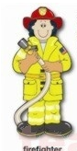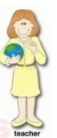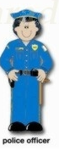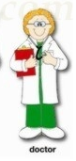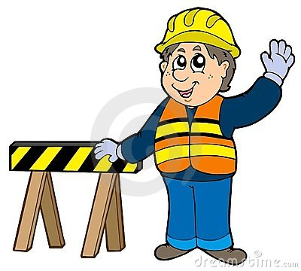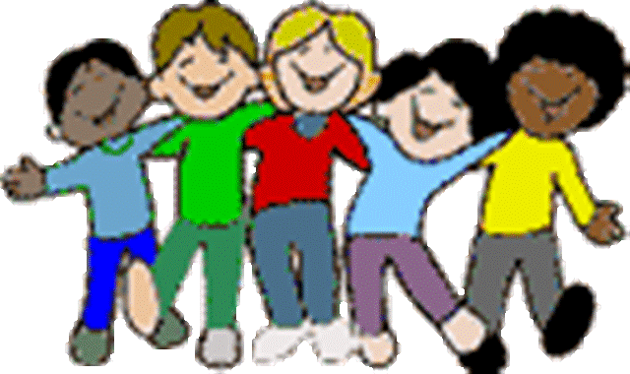
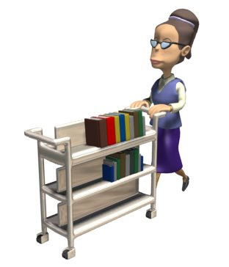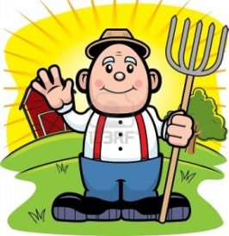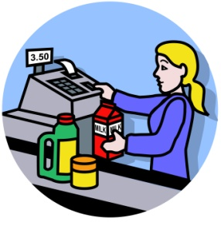

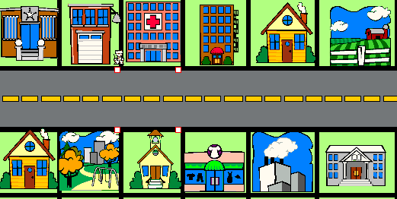
Guest Speaker and Field Trip
During this unit we will have a guest speaker visit the class and also take a field trip to the fire station. Because kindergarteners learn by exploring we will take a class field trip to the local fire station. Prior to the field trip the students will be introduced to community helpers. As a class, we will list multiple community helpers and learn about what people do in our community to help keep us safe. We will take the field trip after lesson #4. In this lesson the students will learn about different community helpers that keep us safe. We will read literature on firemen. We will also discuss the role of a teacher, police officer, and other community helpers that we have listed from previous lessons. Students will be able to talk with a fireman and tour the fire station. Students will ask questions and practice active listening skills while participating in the field trip.
I have asked parents who are interested to come in and speak with the class about how they help the community. After parents have responded I will ask parents to come to speak after I have taught any of the lessons. I hope that I will have enough parent speakers to add a lesson and have a “career” day. During the speakers the students will again practice active listening skills and ask appropriate questions to the speakers.
There will be a lot of planning to have guest speakers come to our classroom. After getting permission from the principal I will allow parents to speak for a short amount of time. I will look at their schedule alongside ours and see what time works best. Since the planning cannot be done until parents have responded I will need to make sure parents that want to speak have requested to do so a few weeks before the initial lesson has been taught.
Following the field trip and guest speakers, we will discuss what we have learned and will use a Venn diagram to compare and contrast the differences between 2 of the community helpers that spoke.

Technology and Literature
Technology will not be a teaching strategy while teaching this unit. After thinking about incorporating technology I decided that hands on activities alongside literature would be the most beneficial strategies to teaching my students about community.
I plan on incorporating literature into the lessons that make up this unit. Each book was chosen carefully and will be used as motivation and a teaching aid into introducing and reviewing material. I also plan on setting aside literature for the children to look. Students can look at these books during writer’s workshop and use them when they are working on their unit projects. These books will be books that we discussed during the lessons and also books that are about different community helpers we have discussed.

Pre and Post test Assessments

Pre-test
Class:
- A class KWL chart will be created. This chart will be on large poster board and filled out prior to first lesson. The teacher will ask the students what they know about community. Next the students will generate questions they want to learn about community and additional lessons and activities can be added to unit plan if students are curious about a top not covered in the current lessons.
- Students will be introduced to a community web and students will add on after each additional lesson. Web will be on giant poster with room to add additional information to show growth during unit.
Individual:
- A piece of paper will be given to students to draw what community means to them. Tell students to include messages and pictures to tell what community is, who is in our community, and anything else they know about community. The individual assessment needs to be given before the class assessment. Rubric will be used to assess, however accuracy of message will not be taken into account.

KWL Chart (Not to scale)
K | W | L
Fill out prior to teaching lesson 2 | Fill out prior to teaching lesson 1 | (This will be left blank until post test)

Community Web (Not to scale)
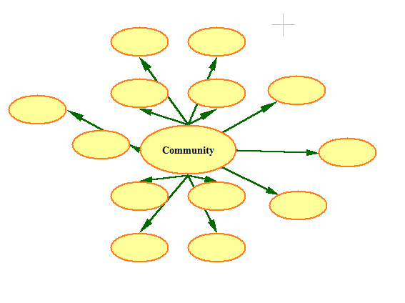

Rubric
3 2 0-1
Message | Message goes along with pictures and starts at upper left. | Message does not start at the upper left. | No message
Punctuation | Punctuation | Punctuation is used incorrectly | No Punctuation
Picture | Pictures look real (Color, size) and are neat | Pictures do not look real (Color, size) but are neat. | Scribbles and sloppy.

Post-Test
Class:
- The KWL chart will be brought out again and class will write about any additional questions they have about community and what they have learned about community. The KWL chart will be used to compare growth in class as a whole during the unit plan.
- Look at and complete community web.
KWL Chart (Not to scale)
K | W | L
Filled out previously | Filled out previously. Add on if needed | Fill out after completion of unit

Community Web (Not to scale)

Individual:
- A piece of paper will be given to students to draw what community means to them. Tell students to include messages and pictures to tell what community is, who is in our community, and anything else they know about community. The individual assessment needs to be given before the class assessment. Rubric will be used to assess and accuracy will be assessed.

Rubric
5-4 points 3-2 points 1-0 points
Accuracy | Student defines community | Student somewhat defines community | Student does not define community
Message | Message goes along with pictures and starts at upper left. | Message does not start at the upper left. | No message
Punctuation | Punctuation | Punctuation is used incorrectly | No Punctuation
Picture | Pictures look real (Color, size) and are neat | Pictures do not look real (Color, size) but are neat. | Scribbles and sloppy.

Lesson Plan #1
Incorporated: Reading and Music
Lesson: Friendship
Length: 30 min
Age or Grade Level Intended: Kindergarten
Academic Standard(s):
Social Studies:
K.2.1 Give examples of people who are community helpers and leaders and describe how they help us
Language Arts
K.1.22 Listen to stories read aloud and use the vocabulary in those stories in oral language.
K.3.3 Identify characters, settings, and important events in a story.
Performance Objective(s):
The student will identify at least 3 characteristics of a friend on a piece of paper.
Assessment:
Assessment will be worksheet completion and if the child can describe/draw 3 characteristics of a friend.
Advance Preparation by Teacher:
- Locate book, The Rainbow Fish by Marcus Pfister
- Copies of Friendship Song
- Copies of A Friend is…
Procedure:
Introduction/Motivation:
Begin class by singing Friendship Song. Tell the class that today we are going to talk about our friends. Have students name characteristics of friends. Make a chart of pictures while brainstorming as a class. (Gardner, Musical)

Step-by-Step Plan:
1. Have students close their eyes and picture a good friend. Record their responses to the following questions in the chart that you have made or used (an example is at the bottom of this lesson) (Gardner, Visual-Spatial)
* What does a friend look like? (nice, smiling, kind, etc.)
* What does a friend sound like? (cheerful, funny, loud, etc.)
* What does a friend act like? (shares, plays, laughs, etc.) (Bloom’s, Knowledge)

2. Introduce The Rainbow Fish. Tell students that you are going to read them a story about a lonely little fish that learns to make friends. Tell them to keep in mind what a friend looks like, sounds like, and acts like while they listen to the story.
3. Read the story aloud. After reading, encourage students to add ideas to the chart. How did Rainbow fish look, sound and act after he made friends? (Gardner, Verbal-Linguistic) (Blooms, Knowledge) Discuss why he might not have friends in the story. (Blooms, Synthesis)
4. Guide the students to recognize that the rainbow fish was lonely until he started acting like a friend and became a part of a community. (Gardner, Interpersonal)
What is a community? (Blooms, Knowledge)
Our class is a community
Our town is a community (etc.)
5. Explain that our friends and family are part of our community and that a community is a group that lives, works, or plays together.
6. Give each student a piece of paper and tell them to draw what they think a community looks like. (People, family, friends, class, etc.) (Gardner, Visual-Spatial)
7. Next explain that tomorrow we are going to see how a community plays, lives, and works together.

Closure:
After you have reflected tell students that there are many people in our community. A lot of people help us in our community such as firemen and police officers. Tell students that later in the unit we will be learning about people in our community that help keep us safe.

Adaptations/Enrichment:
Student with Learning disability in reading comprehension: Give student a copy of their own book so he/she can look at the pictures as it is being read. Make sure you are asking comprehension questions throughout the book and asking if anyone has any questions to keep students involved and help student comprehend the story.
Student with ADHD: Have student with ADHD sit by you as you read the story and make sure if student becomes disengaged to ask a question to the specific student.
Student that has gifts in creativity: Have student when finished work on the poster drawings. Have students draw a little picture next to each positive way that we wrote down as a class, or give suggestions on what we should draw next to each friendship skill.

Self-Reflection:
Can my students identify different characteristics of friends?
Was the chart helpful to students when brainstorming?
Was kickball the wrong game? What else could I have played?
Did I have enough verbal directions for my students to understand the assignment?
Was this assignment too easy?
Was this assignment too hard?
What would you recommend to help me help you with this assignment? (Bloom: Evaluation)

Adapted from.
http://learningtogive.org/lessons/unit194/lesson4.html

A Friend Is...
A Friend . . .

(Looks like)
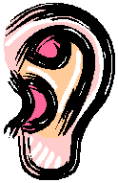
(Sounds like)
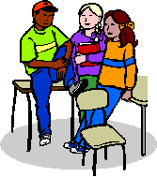
(Acts like)

Friendship Song
(Sing to the tune of "You Are My Sunshine")

You are my best friend,
My very best friend,
You make me happy,
Everyday,
You share your great snacks,
You share your best toys,
So please don’t take
My best friend away.
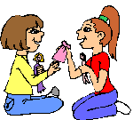

Lesson Plan # 2
Incorporated: Reading, Music and PE –Gross Motor
Lesson: Friendship Review and Application
Length: 30 min
Age or Grade Level Intended: Kindergarten
Academic Standard (s):
Social Studies
K.2.3. Give examples of classroom and school rules and explain how each help us
K.2.5 Identify the role of students in the classroom and the importance of following school rules to ensure order and safety
Language Arts
K.3.2 Retell (beginning, middle, end) familiar stories
K.7.2 Share information and ideas, speaking in complete, coherent sentences
K.7.1 Understand and follow one and two-step spoken directions
Physical Education
K.1.1 Perform basic (fundamental) locomotors skills
K.1.3 Perform basic manipulative skills
Performance Objective(s)
In a game of kickball students will play according to the rules 100% of the time.
Assessment:
Observe how students behave toward each other in game. Using a checklist teacher will check if each student is playing according to rules that were discussed in class.
Advance Preparation by Teacher:
- Obtain a copy of The Rainbow Fish by Marcus Pfister
- Copies of Friendship Song
- Copies of A Friend is…
- Find play area and equipment for kickball
Procedure
Introduction/Motivation:
Begin class with showing the cover of The Rainbow Fish that was read the previous lesson. Have students summarize what the story was about. Why do you think the rainbow fish did not have friends? (Blooms, Knowledge) What are characteristics of a good friend? (Blooms, Knowledge) Remind students about the last lesson and what was discussed. Sing the Friendship Song. Students should be familiar with song since it was sung several times in the previous lesson. (Gardner, Musical)
Step-by-Step Plan:
- Tell students that today we are going to play a game but in order to play we all have to follow the rules. Why do we have rules?
- Ask students to state some rules they may have at home or that we have in the classroom. What is the importance of having these rules?
- Guide the students realizing that we have rules to keep us safe.
- Tell the students that today we are going to play a game of kickball. What are some rules we should follow to keep us safe. Create a list of rules. Think aloud: Mmm, some of these rules look familiar. I think that if Rainbow Fish were to follow these rules he would have been able to find friends a lot sooner than he did.
- What are some characteristics of friends we talked about? Review the chart that was previously made. Ask the students to explain how they can look, sound and act like friends while they play a game of kickball together. (Bloom’s, Analysis)
- Have students turn to partners to list and practice some things they can say, what they should look like, and how they should act while they are playing together. (Bloom’s Analysis)
- Play kickball as a class. Tell students that during this time we are going to demonstrate how to be good friends and follow the rules. Take time to stop and point out things that are friendship skills and things that maybe are not friendship skills. (Gardner, Bodily-Kinesthetic) (Bloom’s, Comprehension)
- At the end of the game have students talk about what happened during the game. How did it go? Was everyone acting like a good friend (do not tell students to tattle, just to be talk about what happened during the game). (Bloom’s, Evaluation)
Closure:
After you have reflected tell students that there are many people in our community. A lot of people help us in our community such as firemen and police officers. What other community helpers keep us safe? Tell students that later in the week we will be learning about people in our community that help keep us safe.
Adaptations/Enrichment:
Student with physical disability: Teacher will always be the “pitcher.” Adjust speed according to student’s disability. If student is unable to kick, pick a different game such as T-ball (which is currently being practiced in PE)
Student with ADHD: Student should be engaged in activity since it is hands on. If student becomes distracted have students switch positions throughout each inning. Share cheers and friendly sayings that children can say while waiting their turns to kick the ball.
Student that has gifts in creativity: Have students describe an event in the game where students used good friendship skills (for example: cheering for each other, encouraging, or saying good game at the end that shows sportsmanship). Have student with gifts in creativity draw a picture of the even that was described so it can be posted outside the classroom under a description of what was done and what goals were achieved during the activity. (Gardner, Visual-Spatial)
Self-Reflection:
Can my students identify different characteristics of friends?
Was kickball the wrong game? What else could we have played?
Did I give enough verbal directions for my students to understand the assignment?
Was the assignment too easy?
Was the assignment too hard?
What would you recommend to help me help you with this assignment? (Blooms, Evaluation)
Adapted from
http://learningtogive.org/lessons/unit194/lesson4.html

Student’s Name | Student followed all the rules | Student followed all but 1 rule | Student did not follow more than 1 rule
Student A
Student B
Student C

Friendship Song
(Sing to the tune of "You Are My Sunshine")

You are my best friend,
My very best friend,
You make me happy,
Everyday,
You share your great snacks,
You share your best toys,
So please don’t take
My best friend away.

Lesson Plan # 3
Incorporated: Reading
Lesson: People of our Community
Length: 30 min
Age or Grade Level Intended: Kindergarten
Academic Standard(s):
Social Studies
K.2.1 Give examples of people who are community helpers and leaders and describe how they help us
Language Arts
K.1.1 Identify the front cover, back cover, and title page of a book.
K.1.22 Listen to stories read aloud and use the vocabulary in those stories in oral language.
K.2.1 Locate the title and the name of the author of a book.
Performance Objective(s):
Given five community members, students will match at least four correctly to the appropriate tools.
Assessment:
Bingo- teacher will collect bingo cards to check for comprehension and collect worksheet at end of lesson.
Advance Preparation by Teacher:
- Prepare bingo card (copies)
- Collect pictures in community and tools (same that are on bingo cards)
- Obtain a copy of When I Grow Up by Tina Louise
- Make copies of worksheet

Procedure:
Introduction/Motivation:
Talk about how yesterday we practice being part of a community. It was important to follow rules so we could work together to have fun. Who are some other people in our community that we have talked about? Do they work together to help our community? How so? Show the cover of When I Grow Up. Ask students to point out the front/back cover, title, author and illustrator which we have been talking about in previous lessons. Read the title. Ask students what they think the book is about (Blooms, knowledge). What do you want to be when you grow up? Have students turn to elbow partners and talk about what they want to be when they grow up. (Gardner, Interpersonal) Tell students that today we are going to learn about different people in our community. What is community? (Blooms, Knowledge) Who are some people in our community? (Blooms, Knowledge) Read the book to students. (Gardner, Verbal-Linguistic)
Step-by-Step Plan:
1. Make a list on board of different people in our community and have pictures available of multiple community members to put next to names. (Gardner, Visual-Spatial)
2. Tell students that for each person in our community they have tools to help them help us.
What are tools? (Blooms, Knowledge)
When students answer with hammers, nails, Etc., tell students that those things help us build something. Then say that tools help people help us. A doctor uses a stethoscope and thermometer. Stick pictures under the doctor picture. Discuss the different community helpers in book and ask them what tools may help each person of our community.
Students- pencils, brains, paper Etc.
Baker- needs ingredients, cakes, Etc.
Construction worker- needs tools
Doctor needs a hospital, stethoscope, thermometer, Etc.
Dentist- needs x-rays, teeth
Postman- mail
Police officer- handcuffs, police car, dog, Etc.
Teacher- students
Fireman- oxygen, fire truck, water,
Vet- Animals
4. Tell students to turn to elbow partners again and determine what tools they will need in order to do what they want when they grow up. (Gardner, interpersonal)
5. Tell students that now we are going to play a game.
Pass out the bingo cards and explain the rules. Tell students to use crayons to mark the people they have. Once I say a community member and tool they use, use your crayon to draw either a triangle, circle, or square around the person. I will let you know what shape to draw so make sure you are listening carefully so you can draw the right shape if you have the community member. If you get three in a row, raise your hand so we can check together. (Gardner, Bodily-Kinesthetic)
6. Play the game a few times and have additional cards to give out. Tell students to write name on top of all papers and collect cards at end of activity. Keep games (make sure you have shapes and community members pre-chosen so you know what was called in each game) separated so you can check for comprehension of both shapes and community members.
Closure:
Tell students that today we learned about many different community members and later this week we are going to learn more about people in our community that help us keep safe. Do you know anyone that helps keep us safe? (Blooms, knowledge)
Adaptations/Enrichment:
Student with Learning disability in reading comprehension:
Teacher will have student sit close to book so he/she can see pictures. Make sure questions are asked frequently to help student comprehend story and help others with comprehension strategies.
Student with ADHD:
Have student stay engaged in activity by asking him/her questions and having the student collect papers if he/she is getting distracted
Student gifted and talented in creativity:
Have student draw in their notebook what they want to be when they grow up with appropriate tools they will need.
Self-Reflection:
Can my students describe what a tool is used for?
Can my students list different community members?
Did I have enough verbal directions for my students to understand activity?
Did my assessment actually assess student’s comprehension?
Did the book I choose help bring the lesson together or should another one be chosen next time?
What would you recommend to help me help you with this assignment? (To students)
Adapted from:
http://prekinders.com/community-theme/

Community Helpers
Name_______________________ Date______________
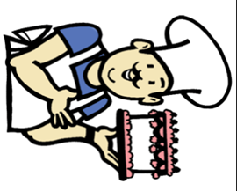 Baker 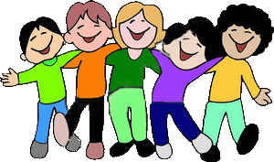
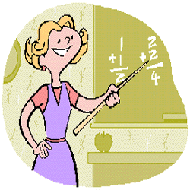 Teacher 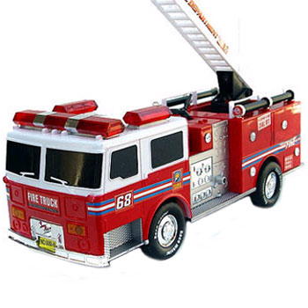
 Doctor 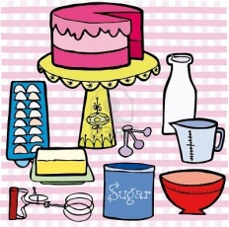
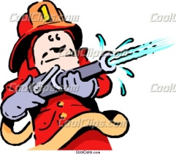Fireman 

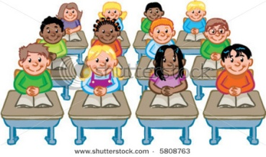Students 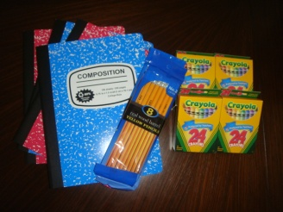

Example Bingo Cards (Can create own)
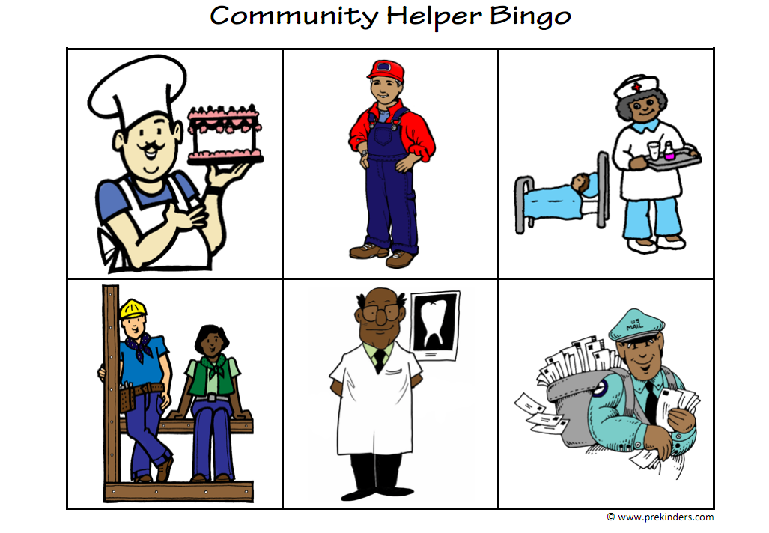
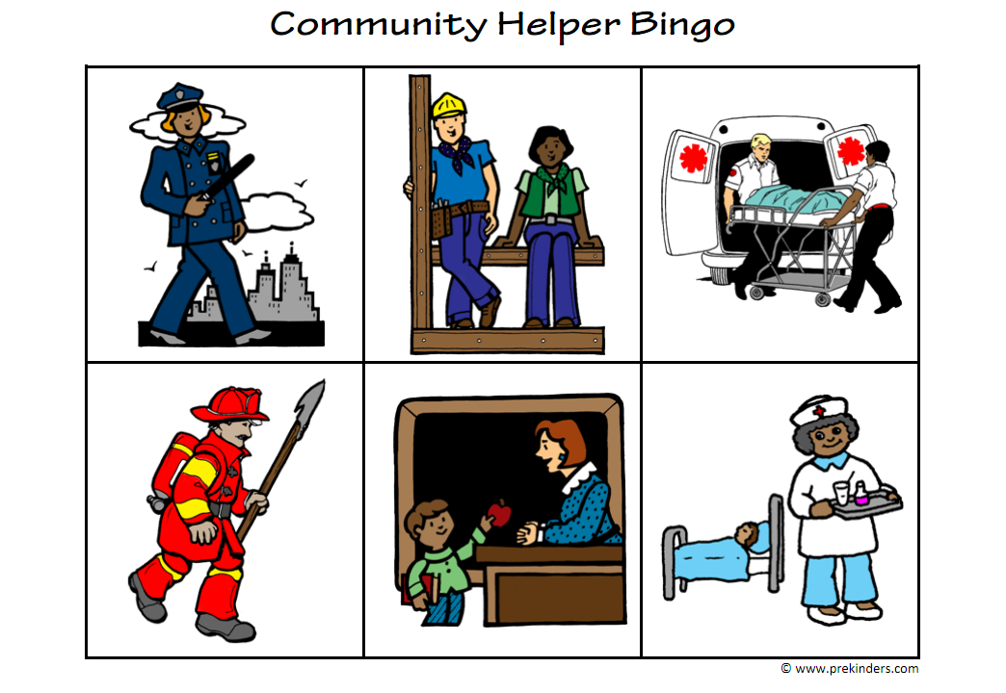

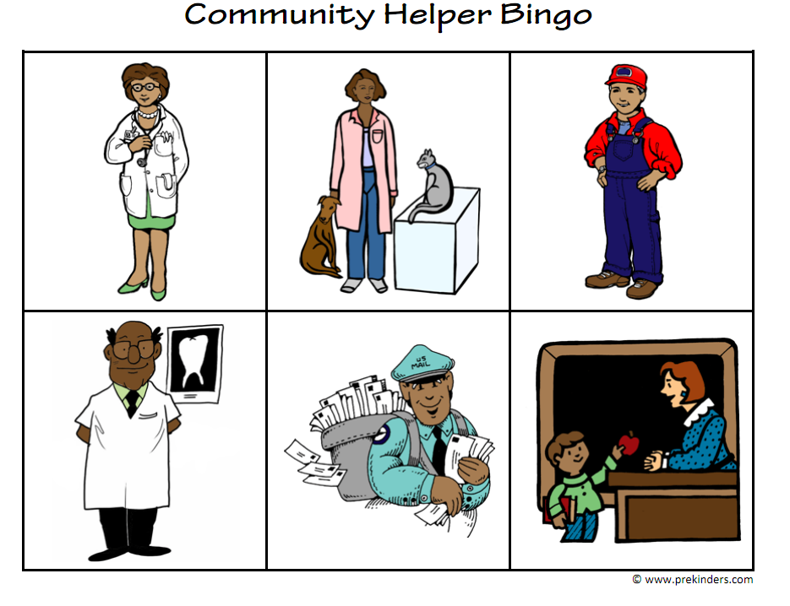
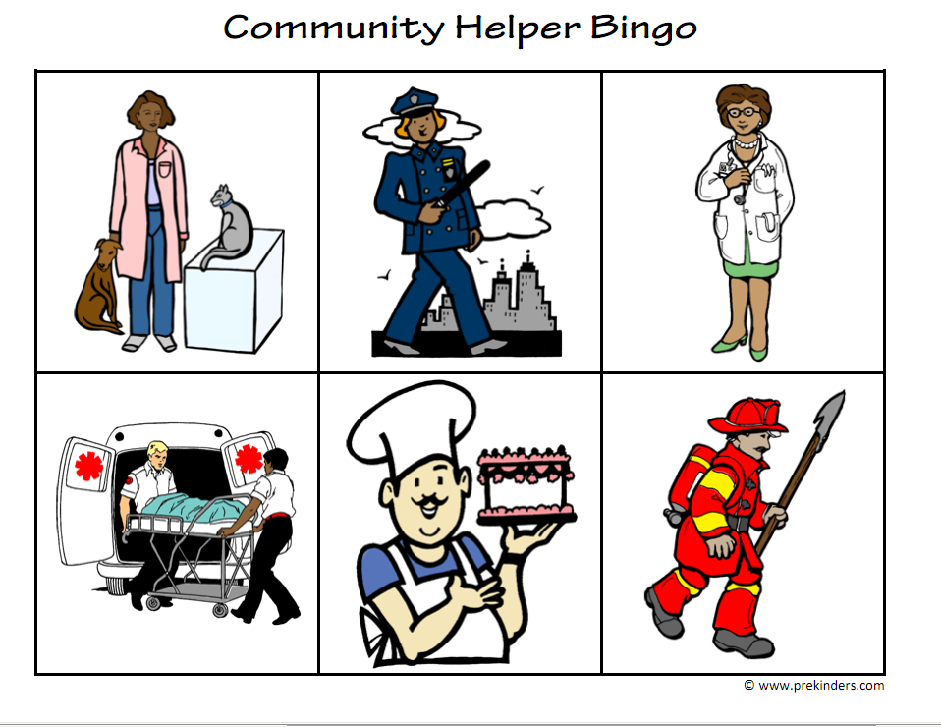
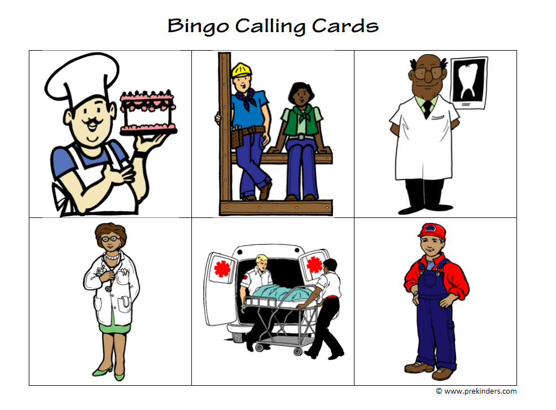
Lesson Plan #4
Incorporated: Story Telling and Reading
Lesson: Safety
Length: 45 min
Age or Grade Level Intended: Kindergarten
Academic Standard(s):
Social Studies
K.1.3 Listen to and retell stories about people in the past who showed honesty, courage, and responsibility
K.2.1 Give examples of people who are community helpers and leaders and describe how they help us
Language Arts
K.4.6 Ask how and why questions about a topic of interest
K.7.1 Understand and follow one and two-step spoken directions
K.7.2 Share information and ideas, speaking in complete, coherent sentences
Performance Objective(s):
Given 5 community helpers, student will match at least 4 community helpers with the appropriate description.
Assessment:
Student will be given a worksheet that has names of community members and pictures of what they do to help our community. Students will match words with pictures. Words will be read aloud to class and students will match pictures after each community member name is read.
Advance Preparation by Teacher:
- Create worksheet and make copies
- Call and arrange a fireman to speak to class and give tour of fire truck.
Procedure:
Introduction/Motivation:
Today class we are going to do something very special. We are going to learn some more about people in our community and how they help us. What are some community members we have named? (Bloom’s, Knowledge) What are the jobs of those community members? (Bloom’s, Knowledge) If students do not bring up firemen, lead them into that community member. After students have shared, restate (from yesterday’s lesson) that some community members have tools to help keep us safe. What about a fireman. What tools does he have? (Blooms, Knowledge) Tell the students that today they are going to get to tour a fire truck!

Step-by-Step Plan:
1. Begin by reading a book about firemen. A suggested book would be, Firemen A to Z by Chris L. Demarest. (Gardner, Verbal/Linguistic)
2. Throughout the book demonstrate think alouds. “I wonder what this community helper does to help?”
3. At the end of the story, ask students to turn to their elbow partners and talk about one thing that they learned. (Gardner, Interpersonal)
4. Bring back to whole group and ask a few students to share what they learned to the class.
5. Next, have students turn to a different elbow partner and discus one question they want to ask the fireman. (Gardner, Interpersonal)
6. Have students line up and lead them outside to where fire truck is. Remind students that they need to be on their best behavior since the fireman is taking time from his busy schedule to share about his job. (Gardner, Bodily Kinesthetic)
7. Allow fireman to share and monitor behavior of students.
8. Have students reflect on what they learned from the fireman. Using a large Venn diagram on the board, compare what the fireman does with a different community member. (Bloom’s, Comprehension)
9. Have students write and draw in their journals about their experience. Make sure to go over the rubric for message, punctuation, and picture which is posted in the classroom. (Gardner, Visual/Spatial)
10. Have students complete worksheet, read the questions and answers carefully for students. (Gardner, Intrapersonal)
Closure:
Tell students that today we learned a lot. What did you learn today? (Bloom’s, Knowledge) Is there another member of the community that helps us? After conversation tell students that next time we are going to learn about policemen. Tell students that policemen have a very important job and they help us stay safe just like firemen do. Explain to students that policemen also use tools during their job and we are going to learn about the tools they use.
Adaptations/Enrichment:
Student with ADHD:
Have student placed near you when fireman is giving his talk. Keep student on track to avoid disruptions. (Student in class usually keeps on track when he is given a certain hand motion which the teacher should use.)
Student that has gifts in creativity:
Student will be able to demonstrate gifts in creativity while writing in journal. Have student, along with others; share their journals with the class.
Self-Reflection:
Was it simple enough to get the fireman to agree?
Did I have enough verbal directions for my students to understand the assignment?
Was this assignment too easy?
Was this assignment too hard?
What would you recommend to help me help you with this assignment?

Adapted from.
http://www.localschooldirectory.com/lesson-plans/id/260

Name: _______________________ Date _______________
Community Members
Directions: Match each community member to the picture that fits best.

1. Doctor 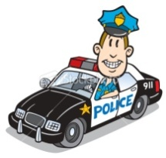
2. Fireman 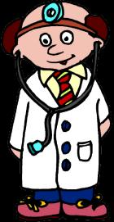
3. Policeman
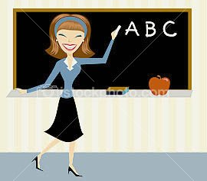 4. Mailman 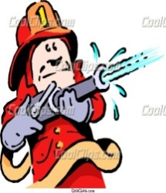
5. Teacher 
Lesson Plan #5
Incorporate: Reading and Writing
Lesson: Community Members review
Length: 45 min
Age or Grade Level Intended: Kindergarten
Academic Standard(s):
Social Studies
K.2.1 Give examples of people who are community helpers and leaders and describe how they help us
K.4.2 Identify and describe different kinds of jobs that people do and the tools or equipment used in these jobs
K.4.4 Give examples of work activities that people do at home
Language Arts
K.4.3 Write using pictures, letters, and words
K.4.5 Write by moving from left to right and from top to bottom
K.4.7 Identify pictures and charts as sources of information and begin gathering information from a variety of sources
Performance Objective(s):
Given a community member, the student will create a poster about their community member and receive at least a 7/10 on rubric.
Assessment:
Use the Journal rubric that is posted on the class wall and the students are familiar with.

3 2 1
Message | Message starts at upper left of page. | Message does not start at upper left of page. | No message
Punctuation | Punctuation | Punctuation used incorrectly | No Punctuation
Picture | Pictures look real (Color, size), and neat. | Pictures do not look real (Color, size) but are neat | Scribbles/sloppy

Names (1 pt) Points __/10
______________
______________
_______________
Advance Preparation by Teacher:
- Make copies of rubrics
- Make a poster with pictures and a message to model the assignment
- Assign groups before hand
- Pick out several books about several different community members for students to look through
Procedure:
Introduction/Motivation:
Show the class your poster. Can anyone tell me what they think my poster is about? (Bloom’s, Knowledge) Have several students share what they think it is about. Tell students that today is a very special day because they get to be the teachers. Can someone tell me what we have been learning about? Wow, we have learned a lot! Today we are going to work on something that we can use to show the whole school what we have been learning!

Step-by-Step Plan:
1. Start off by reading another book about community helpers. Any book from the library will do. A suggested book can be Career Day, by Anne F. Rockwell (Gardner, Verbal/Linguistic)
2. Throughout the book demonstrate think alouds.
3. At the end of the story, ask students to turn to their elbow partners and talk about one thing that they learned. What do they think they want to be when they grow up? (Gardner, Interpersonal)
4. Bring back to whole group and ask a few students to share what they learned to the class and what they want to be when they grow up.
5. Next tell students that they are going to be placed into several groups. Have the groups already made and place students appropriately into groups. (Have books and poster and markers/crayons laid out in a location for students to work on their poster.)
Some community helpers we have talked about that work for group posters: Doctors, Dentists, Policemen, Firemen, Mailmen, Principals/Teachers, and any other community member students have learned about. (Gardner, Interpersonal)
6. Have each student “read” one of the books independently. (Gardner, Intrapersonal) (Gardner, Verbal/Linguistic)
7. Inform each group they can now start working on their poster but need to demonstrate all the different characteristics we have talked about the last few weeks. What are some things we need to remember when being in a group? (Bloom’s, Knowledge) Student responses: Sharing, taking turns, being good friends
8. Demonstrate to students some things they should include on their poster with messages, pictures, or both. Who is your community helper? (Bloom’s, Knowledge) What are the parts of their jobs? (Bloom’s, Analysis)
Scaffold project. Pick one community helper that no student has and make a class poster. Demonstrate what needs to be in each poster. Ask students to suggest pictures, messages, and punctuation that needs to be used when creating a poster. When done display at front of class so students can refer back to the example if they are having trouble.
9. Have students begin on their poster. Tell them when everyone is finished they will share them to the class. (Gardner, Visual/Spatial)
10. Have students share posters to class. Presentation will not be graded just what is stated in the rubric above.
Closure:
That was such a good job!!! I am so proud of everyone. It seems like you have learned a lot about other people in our community. But what about us? Are we part of the community? What do you think we do to help out our community? (Bloom’s, Knowledge) Next time we are going to learn about what we can do to help our community! You are going to be surprised to see that even though we are little we can be community helpers also :]
Adaptations/Enrichment:
Student with ADHD:
Have student answer questions and put in a group where he/she feel comfortable and stay involved. Walk around group to make sure everyone is on task. Do not place student with another student who seems to also get off task. Place student with other students that will keep him/her engaged and thinking at all times.
Student that has gifts in creativity:
Make sure student is placed in a group where you allow their creativity to shine, however, be careful to not place student in a group where they will do all the work. This is a group project.
Self-Reflection:
Was this a good review lesson? Did students know enough information about the community helpers to create a poster and share it with the class?
Did I have enough verbal directions for my students to understand the assignment?
Was their enough time to complete the assignment?
Was this assignment too easy?
Was this assignment too hard?
What would you recommend to help me help you with this assignment?

Lesson # 6
Community Journal Entry
Incorporated: Writing and Art
Standards:
Social Studies
K.2.4 Give examples of how to be a responsible family member and member of a group.
K.3.6 Identify and compare similarities and differences in families, classmates, neighbors and neighborhoods, and ethnic and cultural groups. (Individuals, Society and Culture)
Language Arts

K.4.3 Write using pictures, letters, and words
K.4.5 Write by moving from left to right and from top to bottom
Objectives:
Given a journal, students will acknowledge their role in their community by writing a message and drawing a picture of an act of kindness that helped someone in their community with 80% accuracy.
Needed Materials:
A journal
Crayons
Markers
Pencils

Lesson:
- Stick a picture of a community helper on each student’s back. Ask students to not tell their classmates what community helper is on their back.
- Students will go around asking questions to their classmates to figure out what community helper they have. Once they have figured it out correctly students may look at their community helper and continue to answer questions to help other students figure out their helper.
- Reflect with students. What was hard about this activity? What was easy about this activity? What kind of questions did you ask?
- After students have reviewed the tools and jobs of community helpers ask students, are we community helpers?
- List examples of how we help the community.
- What are some ways you think you help the community each day?
- What does a community helper look like?
- Ask if these characteristics look familiar and show book, The Rainbow Fish. Have students compare characteristics and guide students into realizing that many characteristics are very similar. What are some differences?
- Go over rubric which students are familiar with and explain to students that they will be given time throughout the week to draw a picture and write a message about how they were community helpers. Tell students that today they are going to have to think about what they have done in the past that has made them a community helper.
- Give time for students to write (Option: During writer’s workshop tell students they can add to their community book since they are given freedom to write about anything during this time.)
- Have students pair up and discuss what they wrote about and compare how their picture differed. Were both students being community helpers? What are some other things you did during the day to help be a community helper?
Assessment:
Teacher will use rubric below.
3 2 1
Message | Message goes along with pictures and starts at upper left. | Message does not start at the upper left. | No message
Punctuation | Punctuation | Punctuation is used incorrectly | No Punctuation
Picture | Pictures look real (Color, size) and are neat | Pictures do not look real (Color, size) but are neat. | Scribbles and sloppy.

Occupations to use during introduction activity: (occupations can be repeated)

Lesson # 7
Helping Our School
Incorporated: Art
Standards:
Social Studies
K.3.3 Locate and describe places in the school and community
Objectives:
Given a paper with pictures of different places in and outside of school, students will circle the appropriate pictures that show places in the school with 90% accuracy.
Needed Materials:
Poster board
Markers
Crayons
Test
Lesson:
- Ask students to turn to elbow partners and discuss something they did to help out the community today or something they have wrote about in their community book.
- Tell students you have an idea to help the entire school!
- Tell students that today we are going to help people who come to our school to visit. Who are some of these people?
- Ask students to list off places they may need to go? (Office, library etc.)
  - Teacher needs to create posters with each place on it. (Just words so students can draw around the words) (can be half poster)
  - Place posters on different tables and tell students to pick one poster. Each group will then draw pictures relating to the poster. (Library- books, office- principal, etc.)
- Afterwards we will travel around the school using hallway procedures to locate each spot and hang our posters up.
- How did this help our community? In what other ways can we help our community? Brainstorm to build up for service project lesson.
Assessment:
A formal assessment will be given. Students will circle appropriate places in the school and achieve at least 90% accuracy.

Places in our School
Name_____________________________ Date_________________
Directions: Circle the places that are located in our school building.
Library Post office 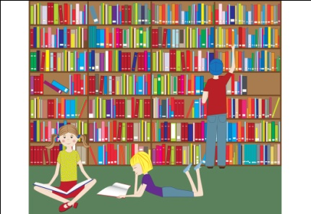 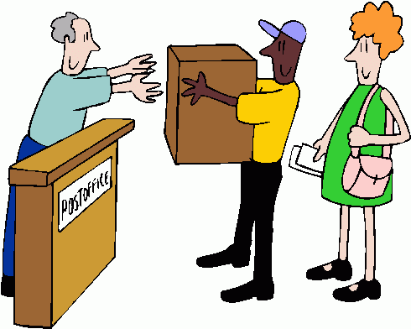
Bedroom Nurse’s office 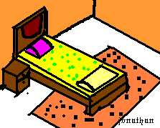
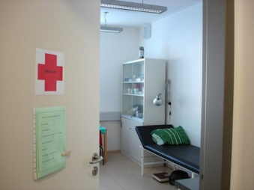 Lunch Room 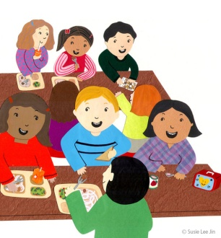

Lesson # 8
Service Project
Incorporated: Storytelling, Math and Technology
Standards:
Social Studies
K.1.3 Listen to and retell stories about people in the past who showed honesty, courage, and responsibility.
K.2.4 Give examples of how to be a responsible family member and member of a group (Individuals, Society and Culture
K.3.7 Recommend ways that people can improve their environment at home, in school and in the neighborhood.
Math
K.2.1 Model addition by joining sets of objects (for any two sets with fewer than 10 objects when joined)
K.6.2 Use tools such as objects or drawings to model problems
Objectives:
Given a job, the student will participate in class service project 100% of the time.
Needed Materials:
Class service project
Appropriate materials to create service project (posters)
Permission forms if needed
Parent speaker or guest from school who works on service projects
Prepare Video (http://www.speakaboos.com/story/arthurs-computer-disaster/)

Lesson:
- Play video of Arthur's Computer Disaster by Marc Brown
- Reflect with students. What was the book about? What problem was Arthur faced with? What did Arthur do to solve the problem? Did Arthur take responsibility? ---Wow!! That’s a big word. Can someone tell me what responsibility means? Do you think Arthur was being responsible?
- What are some ways we can be responsible?
- Turn to elbow partners and talk about how we are able to be responsible.
- Have students share; ask students if they are responsible at school? I think you are very responsible in completing your jobs at school. Do you have jobs at home?
- Does being responsible help us be community helpers? How so? Tell students that today we have a very important guest. She is a very responsible community helper. Let’s use our active listening skills to find out what she does to help our community.
- Introduce speaker and have her speak.
- Ask students to reflect on speaker.
- What can we do to help our community?
  - Food drive or clothing drive is a suggestion.
- Students will create a handout to pass out to school to help with service project. Bring in food, clothes, etc. Teacher will create handout on computer, but students will guide what needs to be said on handout. (time, place, length, etc.)
- Students will each be given jobs (collectors, organizers, “advertisement”, etc.) Jobs will be given in groups to help with responsibility.
- Ask students to count items they have and add them up at the end of each day.
- At end of service project, have students calculate total amount.
- Teacher takes to appropriate drop off spot.
- Ask students to reflect on time that was spent. Why did we do this?
Assessment:
Teacher will use annotated notes and checklist to check for participation. (Absence will not count against student.)
Service Project Cooperation Checklist
Student Name | Student Participated | Student did not Participate
Student A
Student B
Student C

Lesson # 9
Being Grown-ups
Incorporated: Creative Dramatics
Standards:
Social Studies
K.2.1 Give examples of people who are community helpers and leaders and describe how they help us (Individuals, Society and Culture)

K.4.2 Identify and describe different kinds of jobs that people do and the tools or equipment used in these jobs

Objectives:
Given an occupation, student will use the appropriate tools to role play their job in the community 90% of the time.
Needed Materials:
Tools from previous community lesson (money, tools, books, etc.)
Preselected occupations and groups

Lesson:
- We have talked about several community helpers over the last few weeks. Now it is your turn to show me what you have learned!
- Have students review community helpers and ask students to pick one of the preselected occupations to role play.
- Have whole group participate in role play while the rest of the classes guesses what occupation is being demonstrated.
- At end discuss again why tools are important.
- Tell students to think about what they want to be when they grow up because next time we are going to share.
Assessment:
Teacher will use a check list to check for appropriate tools being used during the role play.

Role Play Checklist
5 points 3-4 Points 1 Point 0 Points
Student Name | Participated with all appropriate tools | Participated with some but not all appropriate tools | Participated but with no appropriate tools | Did not participate
Student A
Student B
Student C
Student D

Lesson # 10
What do you want to be?
Incorporated: Writing and Art
Standards:
Social Studies
K.3.7 Recommend ways that people can improve their environment at home, in school and in the neighborhood

K.4.1 Explain that people work to earn money to buy the things they want
Language Arts

K.4.3 Write using pictures, letters, and words
K.4.5 Write by moving from left to right and from top to bottom
Objectives:
Given a journal, student will use pictures and messages to explain what they want to be when they grow up and how they will help the community with 80% accuracy.
Needed Materials:
A journal
Crayons
Markers
Pencils

Lesson:
- Tell students that over the past few weeks they have worked very hard learning about community members.
- Ask students if their home, school and neighborhood are part of the community.
- What are some ways we as part of our community can improve our environment at home, in school and in the neighborhood.
- Have students turn to elbow partners to discuss.
- Why do people have jobs? –To earn money to buy the things we need and want
- What things do we need?
- What things do we want?
- What do you want to be when you grow up? How we you help improve our environment at home, in school and in the neighborhood? Have a few students share.
- Give each student their writing journal and have students draw and write messages showing what they want to be when they grow up and how they will help community. Leave community books out so students can visit them in case they need ideas.
- Students turn to partners to share what they have just written.
Assessment:
Teacher will use rubric below.
3 2 0-1
Message | Message goes along with pictures and starts at upper left. | Message does not start at the upper left. | No message
Punctuation | Punctuation | Punctuation is used incorrectly | No Punctuation
Picture | Pictures look real (Color, size) and are neat | Pictures do not look real (Color, size) but are neat. | Scribbles and sloppy.

Works Cited
Akien, C. (n.d.). Arthur's Computer Disaster Story | Speakaboos Videos. Kids' Stories, Songs, Games, Educational Activities for Children - Speakaboos. Retrieved December 6, 2011, from http://www.speakaboos.com/story/arthurs-computer-disaster/
Cox, K. (n.d.). Pre-K Community Helpers Theme Unit — PreKinders. PreKinders: Website for Pre-K & Preschool Teachers. Retrieved December 6, 2011, from http://prekinders.com/community-theme/
Learning About Firemen Lesson Plan. (n.d.). LocalSchoolDirectory.com - K-12 Public and Private School Reviews, Rankings and More. Retrieved December 6, 2011, from http://www.localschooldirectory.com/lesson-plans/id/260
Nichols-Meyer, M. (n.d.). Lesson Plan - Friends. Learning to Give. Retrieved December 6, 2011, from http://learningtogive.org/lessons/unit194

